You Might As Well Be Walking On The Sun
“UCF steps into the future”

The “Walking on the Sun” Group
Brice McCoy
Daniel Simpson
Greg Boatright
Kyle Cartechine

Table of Contents
(Will add page numbers as document nears completion.)

- Team Member Information
- Work Structure & Team Member Roles
- Problem Statement
- Assumptions
- Milestone schedule
- Initial Design Draft
- Necessary Equipment
- List of figures
- Key Imagery
- References

Team Member Information

Contact Information
Name | Email | Phone
Brice McCoy | brice555@knights.ucf.edu | (xxx)xxx-xxxx
Daniel Simpson | danielsan@knights.ucf.edu | (xxx)xxx-xxxx
Greg Boatright | boatright@gmail.com | (xxx)xxx-xxxx
Kyle Cartechine | kcartechine@knights.ucf.edu | (321)848-1960

Team Member Roles/Strengths
Name | Artwork | Front End Design | Back End Design | Content Man. | Schedule | Budget?
Kyle | x |  | x | x | x
Brice
Greg
Daniel

This chart is very general. Please edit and add more specific tasks then we can all mark what were better at and choose the sections we each feel should be our roles. We can change the layout to have names as top labels and roles as left side labels too if there's several more to add.

Problem Statement
What if the UCF campus was part of a “smart-grid” of green technology that was powered by feet?
- Converting kinetic energy from footsteps into renewable electricity
- How much energy is available for use and what can be done with it?

Assumptions
- There are over 55,000 students and over 10,000 faculty that walk around the campus at some point each day. With other staff, administration, and employees that makes over 100,000 sets of feet that can contribute renewable energy to a “smart-grid”.
- Individuals can be tracked utilizing a RFID module attached to them.
- The primary places to implement the grid include walkways, hallways, sidewalks, doorways, and in various seating configurations (meaning not limited to just classrooms).
- The “smart-grid” technology will be mainly modular and available in many form factors for the common household within five years.
- This green technology will serve commercial and residential construction markets, foreign and domestic.
- It is possible to develop a “smart-grid” in a limited area on campus and have it up and running by April 2013.

Milestones and Schedule
Finalize scope
Finalize plan for deliverable
Finish schedule
Determine materials needed
Complete/compile research
SURE Application 2/15
Finalize Branding
Midterm
Finish web app design/scripting
Finish assembly
Finalize presentation format
Finish presentation
SURE Event 4/5
Final

Product Development Schedule
This would be going beyond the SURE event with pre production, production, and post production.

Initial Design Draft

Necessary Equipment

List Of Figures (Budget?)

Key Imagery
(images from facebook)

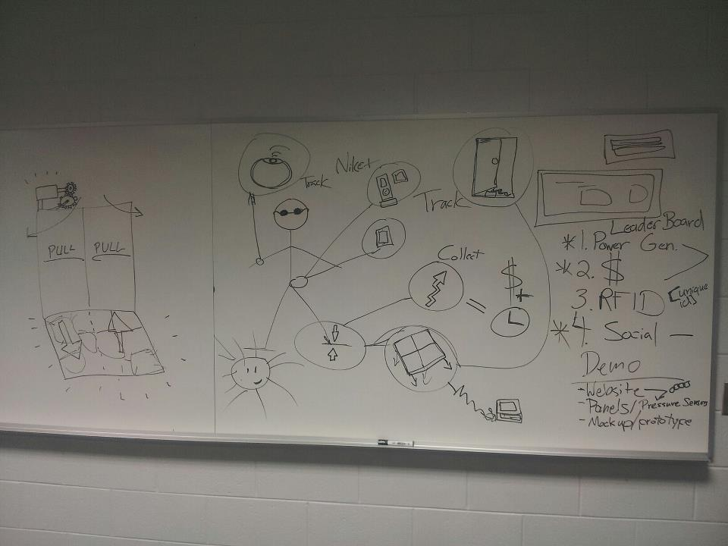
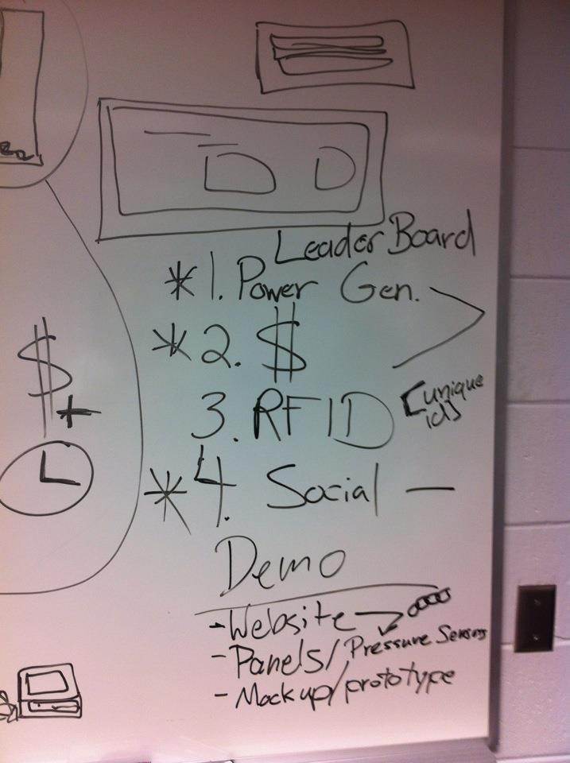
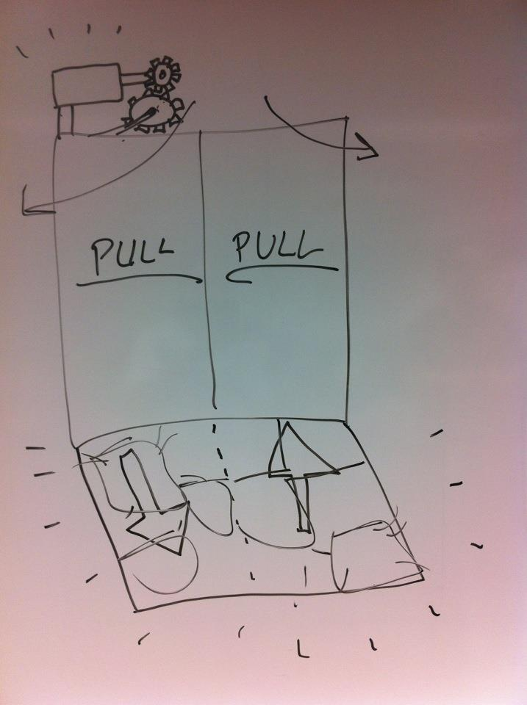

References

One Square Meter:
http://ourworld.unu.edu/en/lets_generate_electricity_by_walking/

Piezoelectric Technology
http://en.wikipedia.org/wiki/Peizoelctric

Generate Electricity by Walking
http://emilychang.com/2009/01/generate-electricity-by-walking/

PAVGEN Systems
http://www.pavgen.com/
http://www.geekosystem.com/pavgen-sidewalk-tiles/

Additional References
http://www.alternative-energy-news.info/human-power-is-the-future/ http://science.howstuffworks.com/environmental/green-science/house-music-energy-crisis1.htm
http://www.hughesresearch.co.uk/index.php?
http://spectrum.ieee.org/green-tech/mass-transit/startups-try-to-capture-road-traffics-excess-energy
http://www.technologyreview.com/energy/24428/
http://www.youtube.com/watch?v=Eam1-9FDD-Y
http://www.youtube.com/watch?v=YFITXmzB9EI&feature=related

